1U Pull-out Fiber Distribution Frame SC 24 Fiber Junction Box Manual
I、Application1U Pull-out Fiber Distribution Frame SC 24 Fiber Junction Box Manual
The product can be used on the terminal of the optical cables, different types and structures, the diameter of which are within 18mm(φ) tray.
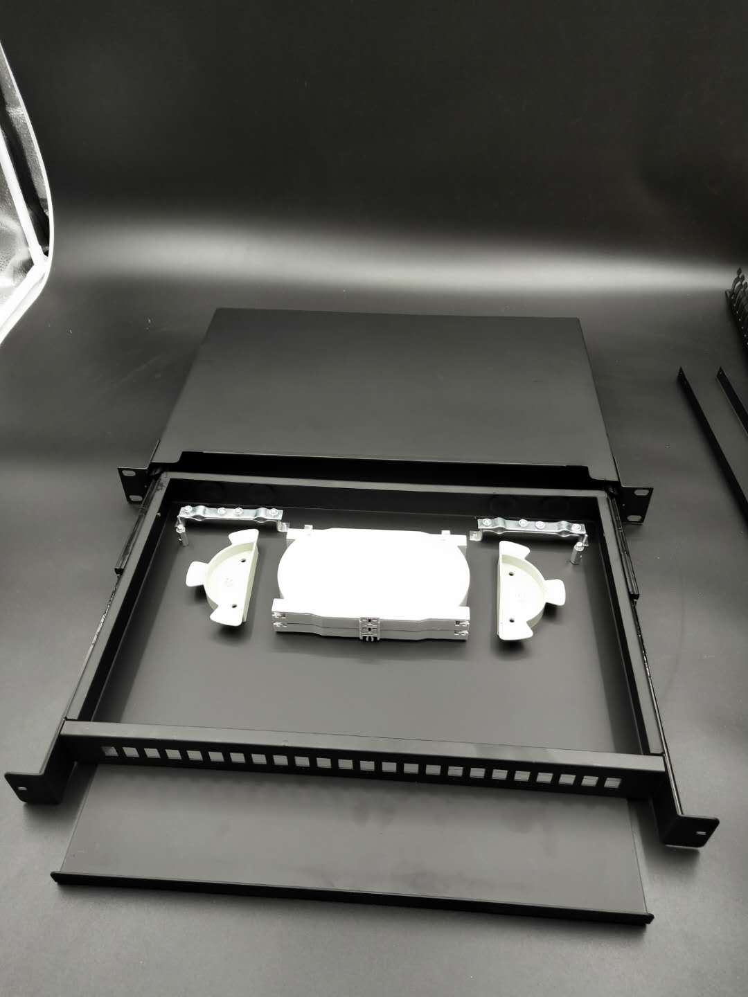
II、Structural features.
- All property indexes are in accordance with National YD/T925—1997 Standard.
- The body make use of cold rolling steel sheet Strong adhesive force, artistic and durable.
- Distinctive design of 1-2 cable entrance and fiber exit of 1-96 cores assures flexibility.
- Cable entrance are sealed with oil resistance NBR to increase the flexibility. Users can choose to prick the entrance and exit.
- Overlapping fiber-melting tray and separate insulation earth unit make the disposition of the cores, expanding the capacity and cable-earthen flexible, convenient and safe.
III、Main technical Specifications
- External Size: (length×width×height) 430x350x1U
- Weight:6.5kg
- optical fiber winding radius: ≥40mm
- extra loss of fiber tray：none
- fiber length left in tray:≥1.6m
- fiber capacity: 48cores
- working temperature: - 400C ~ + 600C
- lateral pressure-resistance: 500N
- shock-resistance：750N
IV、Operations
- Peel the cable , take off the outer and inner housing, as well as loose contract tube, and wash off the filling grease, leaving 1.1～1.6m fiber and 20～40mm steel core.
- Fix the cable-pressing card and the cable, as well as the cable reinforce steel core.
- Lead the fiber into the melting and connecting tray, fix heat contract tube and melted tube to one of the connecting fiber. After melting and connecting the fiber, move heat contract tube and melted tube and fix the stainless (or quartz) reinforce core stick ,make sure the connecting point is in the middle of the housing pipe. Heat the pipe to make the two into one.Put the protected joint into the fiber-laying tray.(one tray can lay 12 cores)
- Lay the left fiber in the melting and connecting tray evenly, and fix the winding fiber with nylon ties. Use the trays from the bottom up. After all the fiber has been connected, cover the top layer and fix it.
- Position it and use the earth wire in accordance with the project plan.
V、Packing List
- terminal case main body: 1 piece
- polishing sand cloth: 1 pcs
- melting and connecting mark: 1 pcs
- heat shrinkable sleeve: 2～24 pcs
- tie: 4～24 pcs

