CSW全自动氩弧（等离子）环缝焊接机
CSW Series Automatic Argon Arc (Plasma) Circular Seam Welding Machine

主要功能与应用
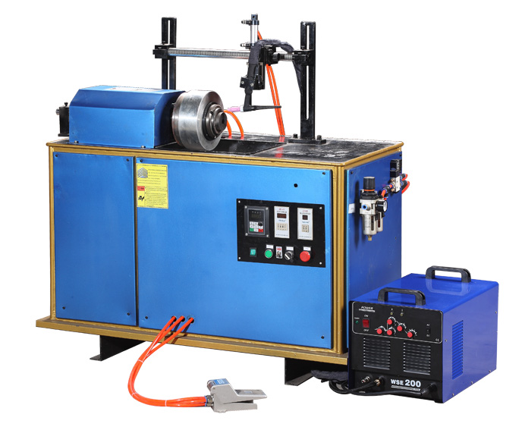

- 全自动氩弧（等离子）环缝焊机主要由特殊设计的环缝机械自动化部分和标准配置的
电源部分.
- 根据具体焊接工件的不同，机械自动化部分包含：卧式环缝自动化和立式环缝自动化。
由我公司特殊设计和制造。
- 标准电源部分包括：TIG（钨极气体保护电弧焊），MIG(熔化极惰性气体保护电弧焊)，
MAG（熔化极活性气体保护电弧焊），SAW（埋弧焊），PAW（等离子焊）等等。可配备的
由我公司制造的高质量标准电源，同时客户也可以先用其他知名品牌的电源，通用性非常强。
- 工件回转由变频电机+减速机+三爪夹紧的驱动方式，运动平稳，无级调速。
- 压紧轴压紧、松开以及焊枪进退均采用汽缸驱动，并且焊枪具有精密微动调节机构，以
便焊枪与焊缝形成最佳方位。
- 控制系统采用微电脑集成化控制，体积小，操作界面可靠简单，修改维护方便。
卧式环缝自动焊机
Horizontal Type Circular Seam Welding Machine
Main Features and Applications

主要技术参数 Main Technical Parameter
- Automatic Argon Arc (Plasma) Circular Seam Welding Machine mainly includes two parts : specially designed circular seam Automatic Machinery Part and Standard Welding Source Part.
- According to the different request of each welding part, Circular seam Automatic Machinery Part can be designed as Horizontal Type and Vertical Type Circular Seam Welding Machine. Specially designed and produced by our factory.
- Standard Welding Source Part includes TIG (tungsten inert gas shielded arc welding), MIG (metal inert gas shielded arc welding), MAG (metal active gas arc welding) SAW (submerged arc welding ), PAW(plasma arc welding), etc. Automatic Machinery Part can be equipped with the standard welding source manufactured by our company, can also work with other well-known brands of welding power .
- The Workpiece rotation driving mechanism is composed with converter motor, reduction box , and three-jaw clamp, travel steadily with step less adjustable speed.
- Clamp axle and fixing system pressing down , releasing and retreat , welding torch’s action all are driven by air cylinders , furthermore welding torch has been equipped with precision micro-adjustment mechanism to get the best welding position.
- Integrated control system adopts microcomputer control, small size , reliable and simple interface , easily modify and maintenance.
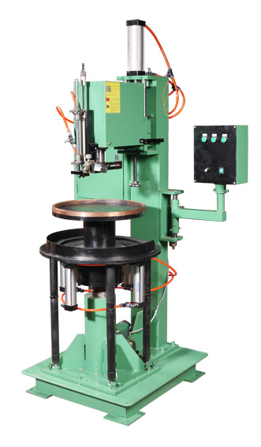
立式环缝自动焊机
Vertical Type Circular Seam Welding Machine
 | 额定输入电源 | Input power supply | 220V/380V/440V/480V, 50/60Hz
 | 电机功率 | Motor power | 50W-1500W
 | 气源压力 | Gas source pressure | 0.4-0.6Mpa
 | 最大焊接工件直径 | Max welding diameter | 488mm
 | 焊接速度 | Welding Speed | 200-1000mm/min

