Specification of Electret
Condenser Microphone
(RoHS Complince)

Customer name:
Customer Model:
LISHEN Model: BO6027ULA42C

AIRUP CUSTOMER APPROVEL

DESIGN: John 2016.7.6
CHKD: Yangjun 2016.7.6
APVD: Vincent 2016.7.6

Tel: +86 15118003085
Fax: +86 339 777 12
E-Mail: 175151958@qq.com
.

KINDS OF SPEC

1. CONSTRUCTION ------------(3)
2. SPECIFICATIONS ------------(3)
3. MEASUREMENT CIRCUIT ------------(4)
4. FREQUENCY RESPONSE ALLOWANCE RANGE ------------(4)
5. MECHANICAL SPECIFICATION ------------(4)
6. RELIABILITY TEST ------------(5)
7. LIST AND STRUCTURE OF MATERIALS ------------(6)
8. PACKING ------------(7)

PLEASE SEND US A COPY, IF YOU APPROVE
1、CONSTRUCTION
Dimensions：Φ6.0×2.7 (Unit:mm)
2、SPECIFICATIONS -40dB（0dB=1V/Pa）=-60dB（0dB=1V/μbar）
No. | Item | Standard
1 | Sensitivity | -42dB±3dB (0dB=1V/Pa)
2 | Output Impedance | 2.2KΩ
3 | Directivity | Unidirectional
4 | Frequency Range | 100-16,000Hz
5 | Operation Voltage | DC 1.0V-10V
6 | Standard Power Supply | DC3.0V
7 | Min Operation Voltage | 1.0V
8 | Current Consumption | ≤0.5mA
9 | Signal to Noise Ratio | ≥65dB
10 | Sound Pressure Level | 110dB
3、MEASUREMENT CIRCUIT
4、FREQUENCY RESPONSE ALLOWANCE RANGE
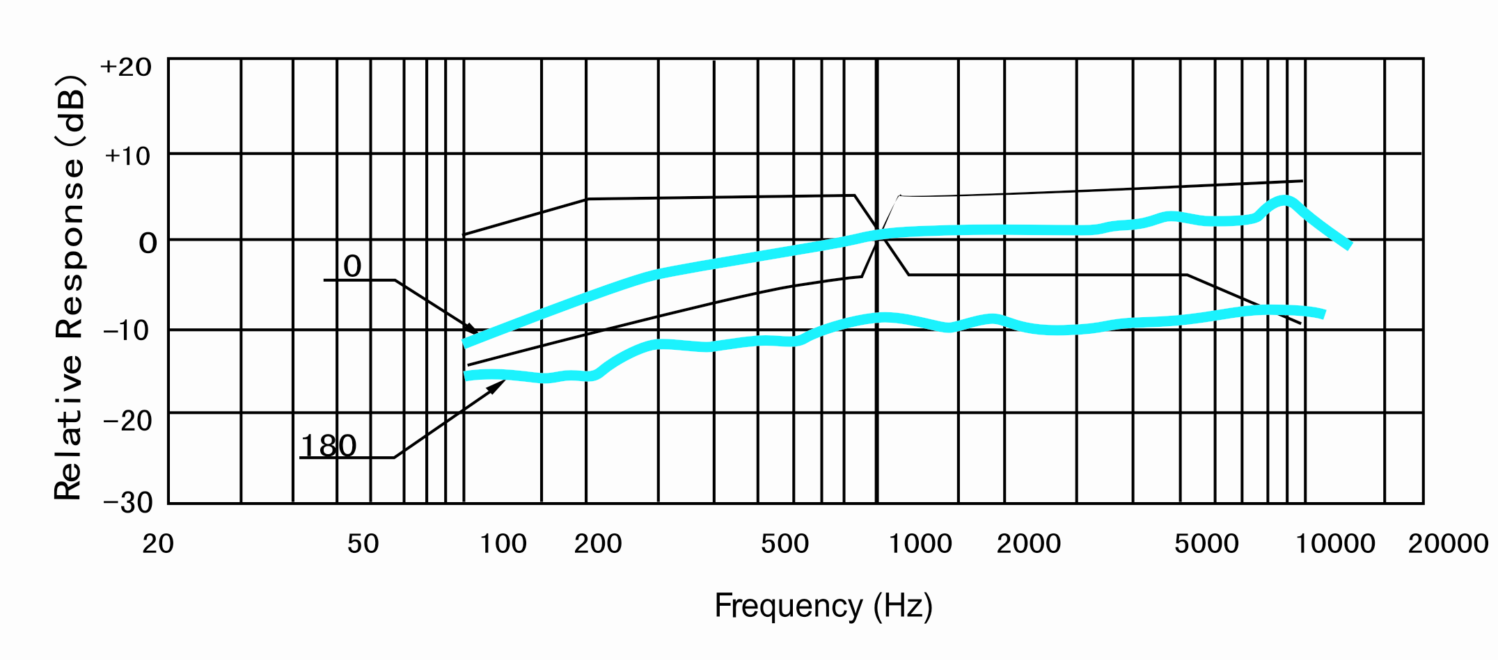
5、MECHANICAL SPECIFICATION
Weight | Less than：0.3g
Soldering Heat Shock | To be no interfere in operation after soldering heat shock, Temperature 320℃ ± 5℃ for 3 ± 0.5 seconds.
Terminal Mechanical Strength | To be no interfering in operation after pulled the terminal with 1kg strength for 1 minute.
Absolute maximum Ratings | Operating Voltage | 10V
Absolute maximum Ratings | Storage temperature range | -25～+70℃
Absolute maximum Ratings | Operating temperature range | -40～+85℃
6、RELIABILITY TEST
Vibration Test | To be no interference in operation after vibration 10Hz to 50Hz for 1 minute full amplitude 1.52mm for 2 hour at three axises.
Drop Test | To be no interference in operation after dropped to concrete floor each one Time from 1 meter height at three directions in state of packing.
Temperature Test | - After exposure at 85℃ for 72 hours, sensitivity to be within ±3dB from initial sensitivity.  (The measurement to be done after 2 hours of conditioning at 20℃)  - After exposure at -40℃ for 72 hours, sensitivity to be within ±3dB from initial sensitivity.  (The measurement to be done after 2 hours of conditioning at 20℃)
Humidity Test | After exposure at 60℃±2℃ and 90 to 95% relative humidity for 200 hours, sensitivity to be within ±3dB from initial sensitivity.  (The measurement to be done after 2 hours of conditioning at 20℃)
Temperature Cycle Test | After exposure at -25℃ for 30 minutes, at 20℃ for 10 minutes, at 70℃ for 30 minutes, at 20℃ for 10 minutes, 5 cycles, sensitivity to be within ±3dB from initial sensitivity.  (The measurement to be done after 2 hours of conditioning at 20℃)

7、 LIST AND STRUCTURE OF MATERIALS

No. | Part name | Material Type | Qty | Origin
1. | PCB | Glass fiber | 1 | China/jiangsu
2. | FET | N-Channel Junction | 1 | Korea
3. | Capacitor | 10PF 0402 | 1 | Murata
4. | Capacitor | 33PF 0402 | 1 | Murata
5. | Case | Al | 1 | China/hebei
6. | Plastic cavity | ABS | 1 | China/shandong
7. | Copper ring | Copper | 1 | China/shandong
8. | Back electrets | ALSET FC-CNZ | 1 | Japan
9. | Spacer | Polyester film | 1 | China/shandong
10. | Diaphragm | PET | 1 | DuPont
11. | FELT | Cotton decron textile | 1 | China/guangdong
12. | Steel mesh | Steel | 1 | China/shandong
13. | Adjust plate | Copper | 1 | China/shandong
8. PACKING
 | DRAWING | QTY(PCS) | SIZE(MM) | MATERIAL | MARKING
PACKING |  | 100 | 61×61×4 | Paper
MIDDLE |  | 1000 | 125×64×27 | Paper
OUTER  BOX |  | 30000 | 230×230×275 | Paper

