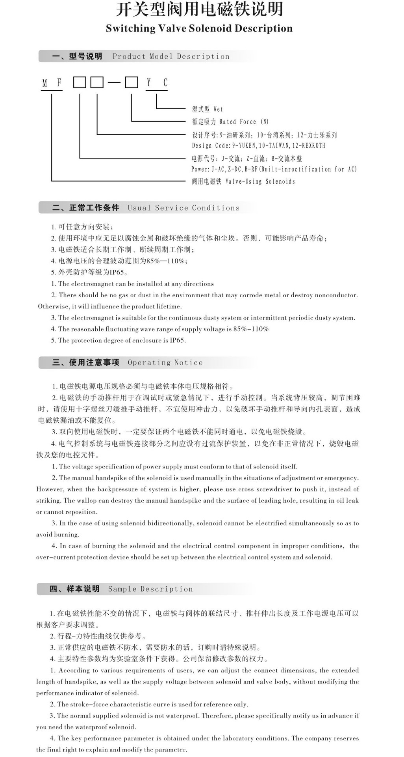
用 途 Purpose
本电磁铁适用于单相桥式全波整流的直流电源，电压至220V的控制电路中，作为液压电磁换向阀的动力元件。可配套于德国力士乐（REXROTH）六、十通径螺纹联结电磁换向阀。
DC power supply in this series of electromagnet is suitable for single phase bridge full wave rectifier, a control circuit voltage to 220V, as the power elements of hydraulic solenoid valve. Can be matched in Germany Rexroth (REXROTH) electromagnetic reversing valve six, ten diameterthread connection.

