HF系列全自动氩弧（等离子）环缝焊接机
HF Series Automatic TIG (Plasma) Circular Seam Welding Machine

整机特性：

- 全自动氩弧（等离子）环缝焊机主要用于不锈钢、铁、铝、黄铜等各种金属的圆形，椭圆形及异形的高质量环缝焊接；
- 根据焊接工件的形状和尺寸可设计成卧式和立式结构；
3. 工件旋转由变频电机+减速机+三爪夹紧的驱动方式，运动平稳，无级调速；
4. 工件压紧、松开以及焊枪进退均采用汽缸驱动，并且焊枪具有精密微动调节机构，以便焊枪与焊缝形成最佳方位；
5. 控制系统采用PLC或继电器集成化控制，操作界面可靠简单，修改维护方便；
- 可任意匹配各种类型弧焊电源（氩弧焊/CO2焊/埋弧焊/等离子弧焊）。

Main Features and Applications
- Automatic TIG (Plasma) Circular Seam Welding Machine mainly used for the high quality circular welding of round shape ,oval shape or special shape made with stainless steel, iron, aluminum and brass, etc;
- According to the shape and size of each welding part, the machine can be designed as Horizontal Type and Vertical Type ;
- The Workpiece rotation driving mechanism is composed with converter motor, reduction box , and three-jaw clamp, travel steadily with step less adjustable speed;
- Clamp axle and fixing system pressing down , releasing and retreat , welding torch’s action all are driven by air cylinders , furthermore welding torch has been equipped with precision micro-adjustment mechanism to get the best welding position;
- Control system adopts PLC or Relay integrated control, reliable and simple interface , easily modify and maintenance;
- Apply to cooperate welding with TIG, MIG, MAG, SAW and Plasma-Arc welding source.

主要技术参数 Main Technical Parameters
 | 额定输入电源 | Input power supply | Single Phase 220V, 50/60Hz
 | 电机功率 | Motor power | 100W-1500W
 | 气源压力 | Gas source pressure | 0.4-0.6Mpa
 | 最大焊接工件直径 | Max welding diameter | 定做（Customized)
 | 焊接速度 | Welding Speed | 300-1500mm/min
机器照片 Machine Pictures：
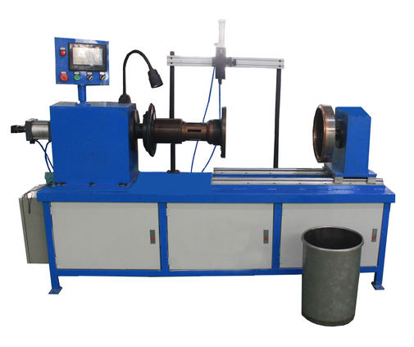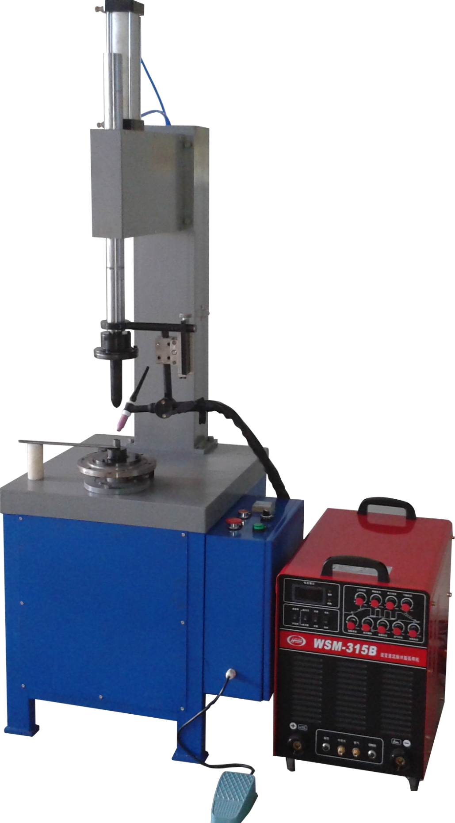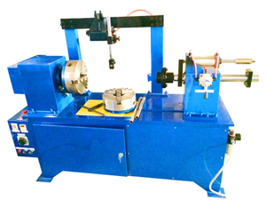

卧式环缝自动焊机 立式环缝自动焊机 卧立式环缝专机

Horizontal Type Circular Seam Welding Machine Vertical Type Circular Seam Welding Machine Horizontal-Vertical Type Circular Seam Welding Machine

