一、概述/Summary
璐然机械厂是专业生产胶水机的生产厂，主要产品有HD型裱纸胶水机、JS型瓦楞裱纸机、YP型滚筒压平机、1000#-1300#压纸架、YC压槽机等产品。/Luran packing machine plant is one professional supplier of adhesive sheet machine. Main products include HD-adhesive sheet machine, JS-flute laminating machine, YP-flatting machine, 1000#-3000# paper press holder, and YC-joint pressing machine.
压纸架主要用于印刷包装行业在瓦楞纸裱纸后压平，是印刷包装行业中不可缺少的设备之一。本机具有压平定型的功能。适用于各类印刷包装纸箱厂。/Paper press holders have been widely used in printing and packing industry for pressing the paper flat after flute lamination, and indispensable in the printing and packing industry. This machine has the function of pressing and fixing, is very fit for the printing and packing paper carton manufactories.

- 技术参数/Technical parameter
- 最大工作面积/Working area (max.):
900mm*1000mm(1000#)
1000mm*1200mm(1200#)
1200mm*1300mm(1300#)
- 最大压力/Pressure (max.): 3t
- 压板行动速度/Pressure plate speed: 72mm/s
- 丝杆直径及导程/Screw diameter and travel range: φ60×1100mm
- 电机功率/Power: 1.5KW/380V
- 电机转速/Speed of engine: 940r/min
- 外型尺寸(长×宽×高)/Size:
1200mm*900mm*1800mm(1000#)
1400mm*1100mm*1800mm(1200#)
1500mm*1200mm*1800mm(1300#)
- 设备净重/Net weight: 1000#型: 300KG
1200#型: 350KG
1300#型: 400KG

- 结构及原理/Construction and theory
本机主要由机架、压板和传动三部分组成。/This machine is made of three parts, which are machine frame, pressure plate and gearing.
通过传动装置控制导向螺杆1和压板7上下运动，和台板10配合达到压平作用。压力限位开关6控制压力，上/下限位开3/5关保护有效的工作行程。压力弹簧4控制压平的力度。/Lead screw 1 and pressure plate 7 are controlled up and down by gearing, and press the products with fixed plate 10. The pressure is controlled by pressure limit switch 6, the up limit switch/down limit switch 3/5 can protect the working travel range. Pressing spring 4 can control the pressing force.
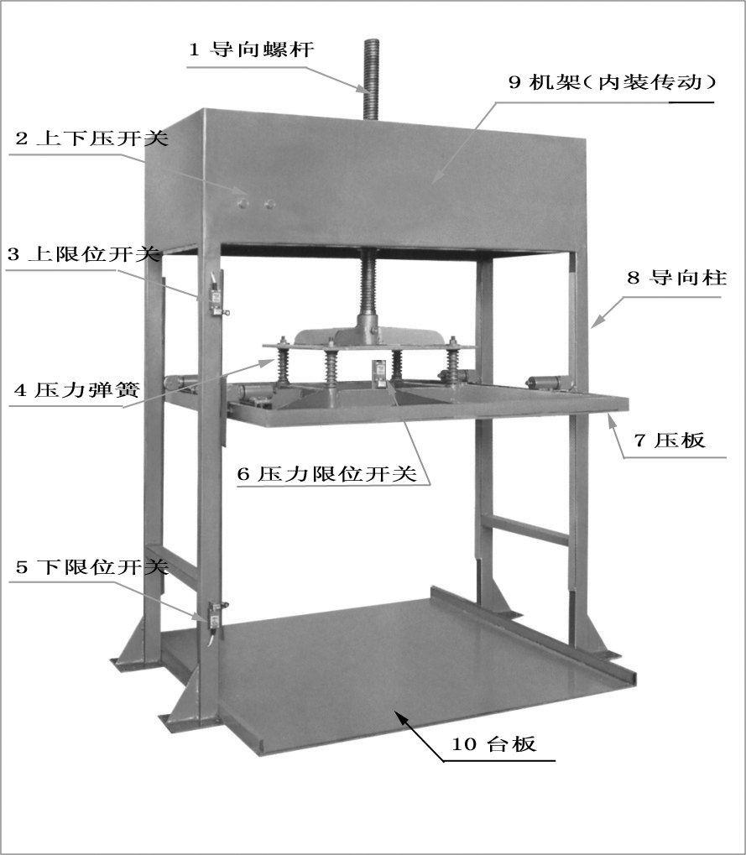
四、使用说明/How to use
接通电源，在台板10的中间放入纸张（纸张高度必须高过下限位开关5），按下压开关2按钮，压板7向下运动，达到适当时纸张即被压紧；待纸张完全贴合压平后，按上压开关2按钮，压板7上升，即可取出纸张。/Turn on the power, then put the papers on the middle of the fixed plate 10 (the highness must be higher than the down limit switch 5). After that, push the down button of switch 2 and get the pressure plate 7 down, when the papers are completely pressed flat, push the up button of switch 2 and get the pressure plate 7 up. In the end, get the papers out.
压板7上下运动方向（可改变电机转动方向来调整）必须同按钮上标示方向一致，否则控制系统失效，损坏机器/The direction of pressure plate 7’s motion must be accordant with the marks of buttons (may adjust the direction by changing the rolling direction of engine), otherwise the controlling system will be invalid and the machine will be broken.
五、维护保养/Maintain
- 开机前要检查电源电压和机器电压是否符合。/Check whether power voltage is accordant with the machine voltage before turn on.
- 机器在调整及检修时,请先切断电源,以确保安全。/Make sure turn off first before adjusting and checking.
- 机器在停止使用时，请关闭电源，可延长电器的使用寿命。/Shut down the power, when stop using, may get longer life for the machine.
- 丝杆与传动螺母之间应经常加注润滑油,使机器运转灵活,平稳。/Regularly fill lubricant oil into the gap between screw and gearing nut, which may make the machine running smooth and stable.
- 应经常注意保持机器清洁，定期检查二组限位行程开关是否有效，以免控制失灵。/Keep the machine clean, regularly check whether the limit switches do work, avoid out of control.

