系统参数表
立式燃油(气)蒸汽锅炉(火管)/Vertical oil (gas) steam boiler (Fire tube)
 |  |  | LHS0.2- |  | LHS0.3- | LHS0.5 |  | LHS0.75 |  | LHS1- |  |  | LHS1.5- | LHS2- | LSS0.1- |  | LSS0.2-
  项目/ltem立式燃油(气)蒸汽锅炉(水管)
 |  |  | 0.4 | 0.7 | 0.7 | 0.7 | 1 | 0.7 | 1 | 0.7 | 1 | 1.25( 顶) | 1(顶) | 1.25(顶) | 0.4 | 0.7 | 0.4 | 0.7
名称/Name |  |  | Y(Q) | Y(Q) | Y(Q) | Y(Q) | Y(Q) | Y(Q) | Y(Q) | Y(Q) | Y(Q) | Y(Q) | Y(Q) | Y(Q) | Y(Q) | Y(Q) | Y(Q) | Y(Q)
额定发热量/Rated head |  | kg/h | 200 | 200 | 300 | 500 | 500 | 750 | 750 | 1000 | 1000 | 1000 | 1500 | 2000 | 100 | 100 | 200 | 200
工作压力/Working pressure |  | Mpa | 0.4 | 0.7 | 0.7 | 0.7 | 1 | 0.7 | 1 | 0.7 | 1 | 1.25 | 1 | 1.25 | 0.4 | 0.7 | 0.4 | 0.7
工作温度/Working temperature |  | ℃ | 152 | 170 | 170 | 170 | 184 | 170 | 184 | 170 | 184 | 193 | 184 | 193 | 152 | 170 | 152 | 170
给水温度/Feed water temperature |  | ℃ | 20 |  |  |  |  |  |  |  |  |  |  |  | 20
热效率/Thermal efficiency |  | % | 90 |  |  |  |  |  |  |  |  |  |  |  | 90
水容量/Thermal efficiency |  | L | 450 | 450 | 660 | 770 | 770 | 1160 | 1160 | 1310 | 1310 | 1660 | 1910 | 2050 | 106 |  | 190
蒸汽出口DN/Steam outlet |  | DN | 40 |  |  |  |  | 50 |  |  |  |  | 65 |  | 20 |  | 32
进水口DN/Inlet |  | DN | 25 |  |  |  |  |  |  |  |  |  | 40 |  | 20 |  | 25
排污阀DN/Sewage Valve |  | DN | 40 |  |  |  |  |  |  |  |  |  |  |  | 25
安全阀DN/Safety valve |  | DN | 40 |  |  |  |  | 40/40 |  |  |  |  |  |  | 40
烟道口/Smoke crossing |  | mm | ￠159 |  | ￠219 |  |  | ￠300 |  |  |  | 320*200 | ￠350 |  | ￠108 |  | ￠159
 | 长/Length | mm | 1100 |  | 1450 | 1500 |  | 1750 |  |  |  | 1950 | 2150 | 2250 | 900 |  | 1100
外形尺寸/Dimensions | 宽/Width | mm | 1100 |  | 1450 | 1550 |  | 1750 |  |  |  | 1800 | 1750 | 1810 | 900 |  | 1100
 | 高/Height | mm | 2150 |  | 2220 | 2240 |  | 2250 |  | 2700 |  | 2700 | 3335 | 3335 | 1750 |  | 1950
运输重量/Transport weight |  | t | 1.12 | 1.16 | 1.57 | 2.34 | 2.41 | 3.08 | 3.16 | 3.55 | 3.71 | 3.16 | 3.61 | 4.24 | 0.72 | 0.75 | 1.11 | 1.22
底座尺寸/Base Dimensions |  | mm | 980 |  | 1190 | 1420 |  | 1600 |  |  |  | 1610 |  | 1710 | 770 |  | 990
 |  | mm | 980 |  | 1190 | 1420 |  | 1600 |  |  |  | 1610 |  | 1710 | 770 |  | 990
燃料消耗/Fuel | 轻油/Light oil | kg/h | 13.0 | 13.1 | 19.4 | 32.4 | 32.8 | 48.5 | 49.3 | 64.7 | 65.7 | 65.7 | 97.1 | 129.5 | 6.5 | 6.6 | 13.1 | 13.0
燃料消耗/Fuel | 天然气(L.N.G) | M³/h | 15.7 | 15.9 | 23.5 | 39.2 | 39.8 | 58.8 | 59.7 | 78.4 | 79.6 | 79.6 | 117.7 | 159.9 | 7.8 | 8.0 | 15.9 | 15.7
燃料消耗/Fuel | 城市煤气/C.G | M³/h | 33.3 | 33.8 | 50.0 | 83.3 | 84.6 | 125 | 126.8 | 166.7 | 169.1 | 169.1 | 250.0 | 333.3 | 16.7 | 16.9 | 33.8 | 33.3
说明:1.天然气热值:8500kcal/Nm³
2.表中数据及图片仅供参考,产品以实物为准,如因改型而变更恕不另行通知;
3.预制、预留、及锅炉房设计前请联系确认有关数据.
4.尾部烟道增设冷凝换热器,使锅炉的热效率提高到96%

热力系统参考
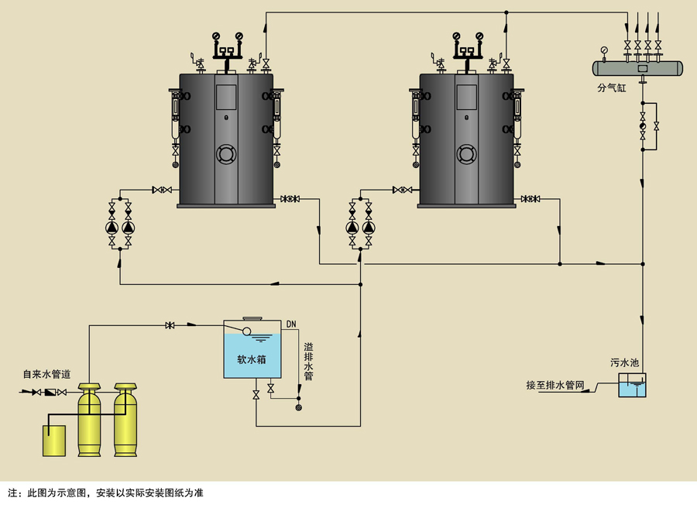
产品尺寸图
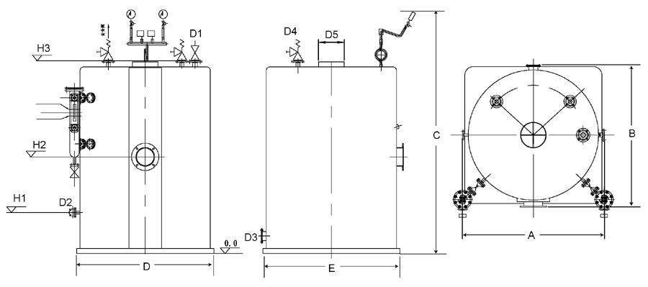
项目 | A | B | C | D | E | H1 | H2 | H3 | D1 | D2 | D3 | D4 | D5
LHS0.2-0.4-Y.Q | 1090 | 1090 | 2616 | 980 | 980 | 400 | 1060 | 2116 | 40 | 25 | 40 | 40 | ￠159
LHS0.2-0.7-Y.Q | 1090 | 1090 | 2616 | 980 | 980 | 400 | 1060 | 2116 | 40 | 25 | 40 | 40 | ￠159
LHS0.3-0.7-Y.Q | 1286 | 1262 | 2720 | 1190 | 1190 | 420 | 1090 | 2220 | 40 | 25 | 40 | 40 | ￠219
LHS0.5-0.7-Y.Q | 1530 | 1530 | 2740 | 1420 | 1420 | 420 | 1060 | 2240 | 40 | 2540 | 40 | 40 | ￠219
LHS0.5-1.0-Y.Q | 1530 | 1530 | 2740 | 1420 | 1420 | 420 | 1060 | 2240 | 40 | 25 | 40 | 40 | ￠219
LHS0.75-0.7-Y.Q | 1728 | 1696 | 2753 | 1600 | 1600 | 480 | 1105 | 2253 | 50 | 25 | 40 | 40 | ￠300
LHS0.75-1.0-Y.Q | 1728 | 1696 | 2753 | 1600 | 1600 | 480 | 1105 | 2253 | 50 | 25 | 40 | 40 | ￠300
LHS1.0-0.7-Y.Q | 1728 | 1708 | 3153 | 1600 | 1600 | 590 | 1280 | 2653 | 50 | 25 | 40 | 40 | ￠300
LHS1.0-1.0-Y.Q | 1728 | 1708 | 3153 | 1600 | 1600 | 590 | 1280 | 2654 | 50 | 25 | 40 | 40 | ￠300
LHS1.0-1.25-Y.Q | 1910 | 1806 | 3190 | 1610 | 1610 | 690 | 1670 | 2590 | 50 | 25 | 40 | 40 | ￠320*200
LHS1.5-1.0-Y.Q | 2510 | 2510 | 3815 | 1610 | 1610 | 590 | 2290 | 3290 | 65 | 40 | 40 | 40 | ￠350
LHS2.0-1.25-Y.Q | 2510 | 2510 | 3815 | 1710 | 1710 | 590 | 2290 | 3290 | 65 | 40 | 40 | 40 | ￠350

